1 Abstract

As technology develops, it is easy for communication access throughout the world. People can easily talk to each other’s. However, online meetings aren’t formal and ideal option for an actual talking. Meeting by person is the only option. However, taking all that bunch of people together is a great problem, considering productivity and cost.
A company will always consider maximizing productivity at the lowest cost. With factors such as jet lag, time zone, distance of flight, food and water, mental health, a model must be created.
In this paper, we will be attempting to develop an algorithm to determine the best meeting places based on these criteria. Obviously, it would be difficult to accommodate all of these factors. As a result, we will only be considering several key factors.
The first key factor is jet lag. We will be determining the best way of measuring this impact as a function of the time difference between the origin and destination cities of each individual. The cities with an overly large productivity loss can then be filtered out, and the best possible region isolated.
Then, the region can be narrowed by decreasing the cost. The best way to decrease the cost is to decrease the distance of flight and thus find the best region to do so.
Finally, within the region, other factors such as climate and service availability will be used to filter out the unnacceptable cities, producing the final list of feasible meeting places.
This algorithm will be tested on two test cases, and the result reported.

2 Introduction

Organizing a meeting is not an easy job, it involves in people from all over the world arriving at a correct time and at a correct place. Also, problems in this organization includes productivity, cost of tickets and accommodation.
To locate an appropriate place for the meeting. An algorithm must be designed to compare locations around the world and determine the best places. The model must be flexible enough to be also able to accommodate different sets of data, and also have a high accuracy.

3 Defining the problem

3.1 Restating the Question

The question requires us to create an algorithm that generates a list of recommended place for holding the meeting given people attending the meeting, home cities and time of the year it is held, and also test the algorithm with the two given data sets.

3.2 Assumptions and Justifications

Assumption 1: No delay is caused by weather, air traffic, accidents or other reasons.
Justification: These factors are extremely difficult to model, and thus the uncertainty is unavoidable.
Assumption 2: The meeting take place in a big city or the capital of a country.
Justification: The meeting will be able to have easy air access that will reduce cost and time.
Assumption 3: The decrease in productivity of jet lag is same for everyone.
Justification: There is not enough material to include this impact.
Assumption 4: All flights will be in the shortest path and at constant speed.
Justification: The flight behavior will be too difficult to model.
3.3 Variables
This is all the variable that we will be using in the investigation.
Symbol | Variable | Definition
t(X ) | Time offset (hr) | The offset of a local time of a location relative to UTC
NA | Timezone | A region which the time offset is the same
NA | Timezone difference (hr) | The difference in local time between two timezones, t(A) − t(B)
l | Jet lag (hr) | The absolute amount of offset of your body clock relative to local time.
L | Overall productivity loss (hr) | the total impact of jet lag l over the course of the meeting
L_{hour} | Total overall productivity loss (hr) | the total of the overall productiv- ity losses of all the participants in the meeting
t | Time (day) | Days since the start of the meeting.
d | Distance of flight (km) | The length of the arc of a great circle connecting the origin and destination of the flight.
NA | Latitude (o ) | The north-south coordinate of a point relative to the equator.
NA | Longitude (o ) | The east-west coordinate of a point relative to the prime meridian.

4 The Algorithm
4.1 Overview
The priority of the algorithm should be to maximize productivity, and then minimize cost. Productivity is mostly associated with jet lag, which will be represented and minimized first with the input of time zone difference. The latter is approximated with the input of distance of flight, which will serve as the criterion for a second stage of selection.
The output variables of the algorithm are a list of recommended cities. To create the list, a region defined by longitude and latitude will be found, and the best cities will be picked out:
- Jet lag will be minimized across 24 time zones to narrow the search region to a longitude range.
- Cost will be minimized across 24 latitude regions to narrow the search to a specific latitude /longitude bound areas.
- The big cities in the area by above will be filtered again for environmental hostility.
4.2 Selecting the time zone
Let us consider a specific person experiencing jet lag. While the impact on productivity definitely increases with the timezone difference, it may not necessarily be a direct linear relationship.
Studies show[1] that our body clock adjusts to time differences at a linear rate, and that this rate varies depending on whether the offset is positive or negative. This gives
a graph like below.
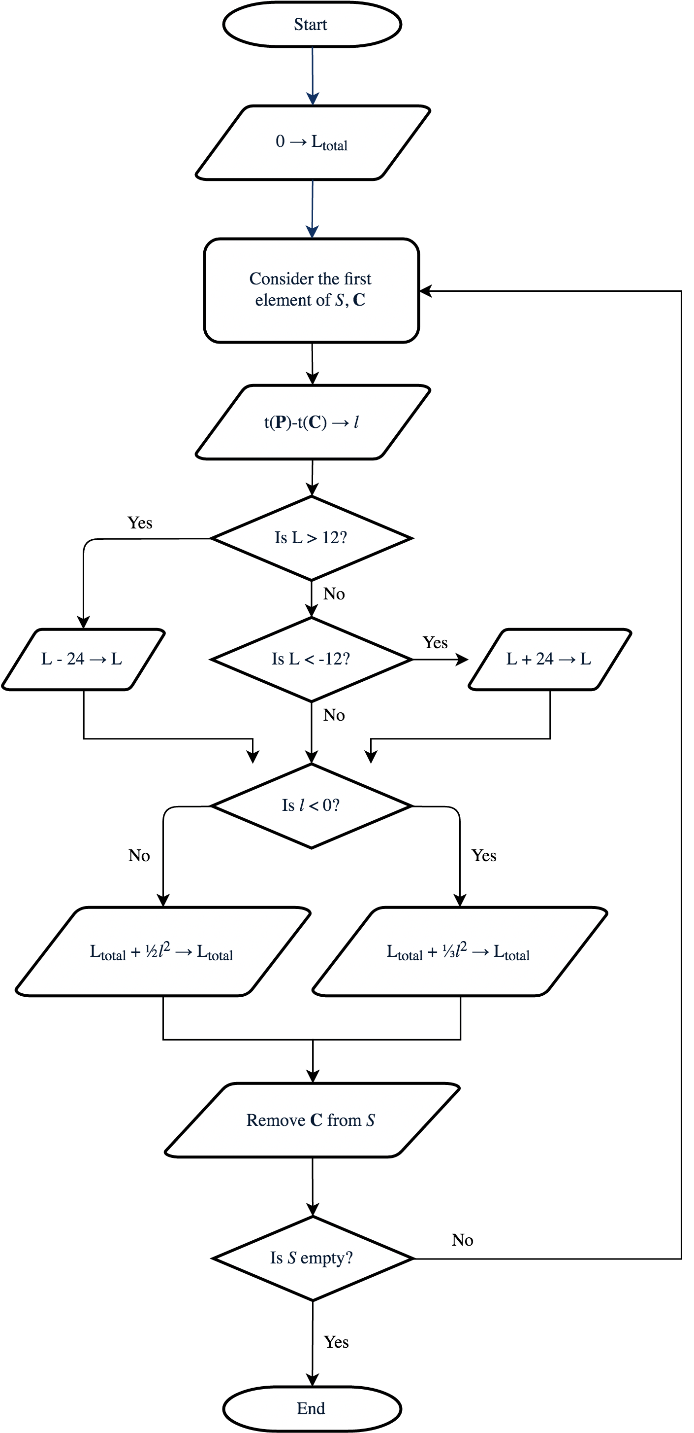
l0
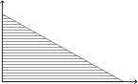
Figure 2: Plotting jet lag (l) against time (t)
Jet lag reflects loss in instantaneous produc- tivity, i.e. the rate at which work is done. Loss of overall productivity, or total work done, would in- stead correspond to 􏰃 l dt, or the shaded triangle,
L = 1l0T.
The rate of recovery in hours readjusted per
day, r, is modeled as a constant. Therefore, it can
be trivially shown that r = l0 . So, T
l02 L = 2r .
For any given original city and time zone, the overall productivity loss L of the individual can be computed with the figure above. Then, the L_{total} can be computed. The time zone with the lowest L_{total} can be selected. It will be meaningless to further narrow down the longitude lines, so we should move on to the next part.
4.3 Selecting Latitude Range
The distances of flight impacts our choice in two ways: for one, a long flight creates stress on the traveler which decreases productivity. But more importantly, it is pos- itively correlated the cost of flight. As a result, it will be used in the second stage of selection to determine the best latitudes.
The timezone will be divided into 12 regions, each spanning 15◦ of latitude and longitude. A phantom city will be placed at the center of each region (coordinates being the average of the latitude and longitude bounds).
The flight distance (d) from a city to a region will be defined as the shortest distance from the city to the phantom city, i.e. the length of the arc of a great circle joining the two points. From the latitudes and longi- tudes of these points, geometry can be then used to determine d for any particular flight.
Let λ and φ be latitude and longitude respectively, and θ be the angle subtended by the arc between the two points. First, project Earth onto a unit sphere in a Cartesian coordinate plane. If the geographical
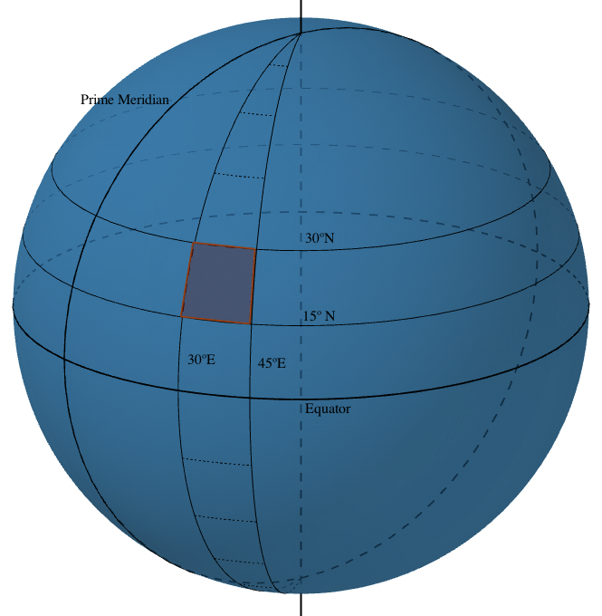
Figure 3: The division of latitude into regions coordinates (0, 0) correspond to Cartesian coordinates 􏰀 0 􏰁, then latitude and longitude represent the
1
rotation of the vector 􏰀 0 􏰁 around the x- and y-axes respectively, in that order. In other words, 1
The angle between the two position vectors, i.e. θ, is the cosine by their dot product (divided by the product of their magnitudes, which is 1). So,
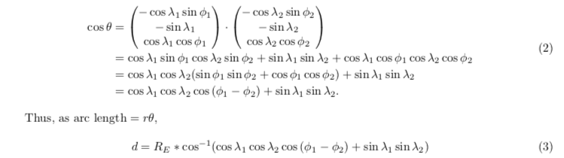

where RE is the radius of the Earth.
Then, we have to attempt to relate distance to cost. According to a study by Rome2Rio[2], cost has an approximate linear correlation with flight distance:
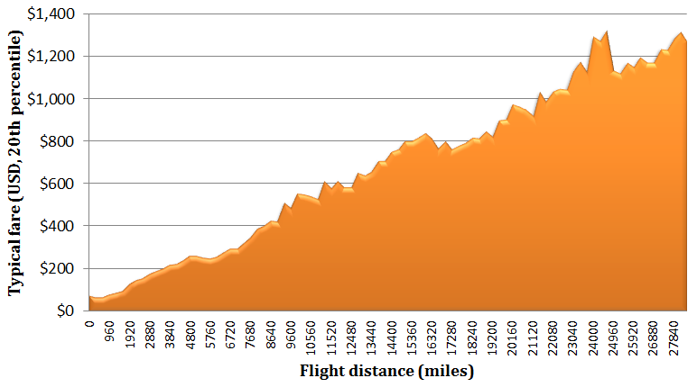
Cost = $50 + Distance ∗ $0.11 (4)
Due to the linear nature of the relationship, the dis- tances can simply be summed to obtain the sort key (in the case of other relationships, the individual costs would have to be summed, as the distribution of flight distance among individuals would influence the total cost).
By calculating the dtotal for each latitude region, the one with the minimum dtotal can simply be selected. The corresponding area will be the new search region. Then, we can move on to the third part.
Figure 4: Ticket price against flight distance [2]

4.4 Filtering the Results
With the region obtained, viable cities must be picked out. To be a viable city, it must have a mean temperature that is between 0 to 35 at that time of the year, and have an airport. Since the city is a big city or a capital, it must have an airport. Therefore, the city only needs to have a temperate temperature.
A too hot and too cold temperature can create loss of productivity during the meeting. So, a medium temperature must be there. However, it is possible that no cities are found within that region, if that happens, refer back to 4.3 and find the next best latitude region. If all latitude region is exhausted, then refer back to the time zone.
4.5 Summary
First, the time zone has been first chosen to minimize the jet lag.
Second, the latitude range is selected to minimize the cost of the meeting.
Third, in this region created by these steps, a city that have a favorable temperature is chosen. If there is no such city, refer back to second step or even first step.

5 Applying the Algorithm
5.1 Small Meeting
The individuals we had to consider are listed in the table below, along with the cities’ timezones and coordinates.

Monterey CA, USA UTC-7
Zutphen, Netherlands UTC+2
Hong Kong (SAR), China UTC+8
Moscow, Russia UTC+3
Melbourne, Australia UTC+11
Shanghai, China UTC+8

Monterey CA, USA 36o 36’14.2344”N 121o 53’54.4560”W
Shanghai, China 31o 0’18”N 121o 24’31”E
Zutphen, Netherlands 52o 8’33.85”N 6o 11’45.81”E
Hong Kong (SAR), China 22o 15’0”N 114o 10’0”E
Moscow, Russia 55o 45’8”N 37o 36’56”E
Melbourne, Australia 37o 49’0”S 144o 58’0”E
In Stage 1, Excel was used to calculate the overall productivity losses L of each city in each timezone, and therefore the total overall productivity losses Ltotal of each timezone. This is shown in Figure 10.
Figure 10: The Excel setup for finding the best timezone (Small Meeting). 12
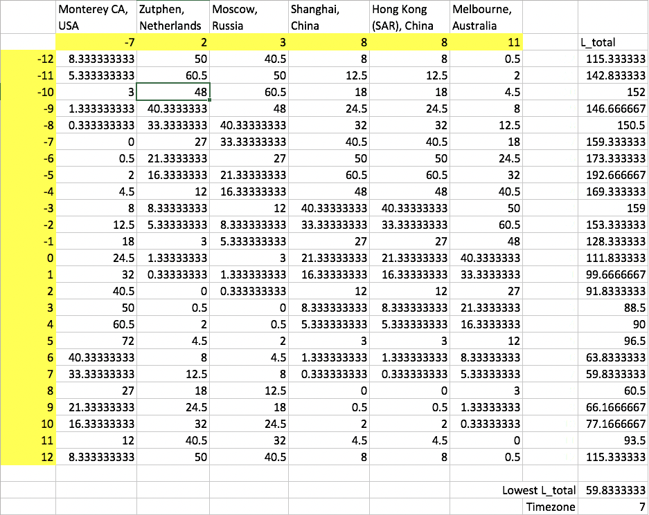
Note that +12 and -12 are the same longitudes; they are included for symmetry only. These values give a graph of Ltotal against timezone, shown in Figure 11.
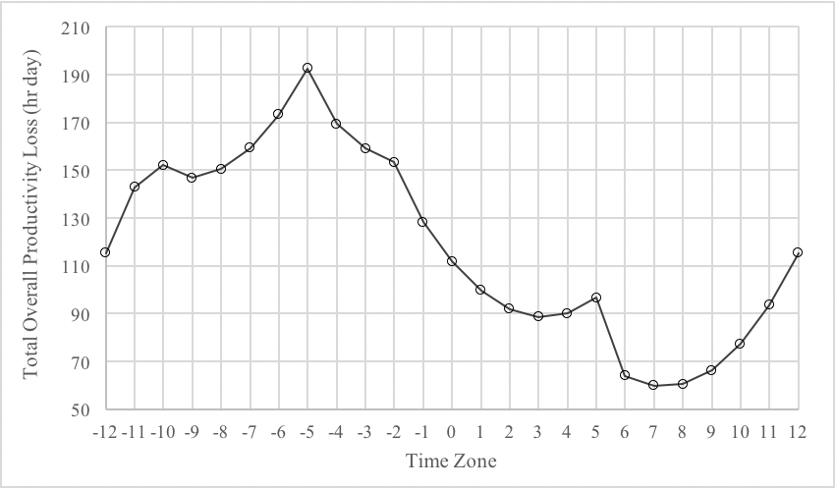
Figure 11: The graph of Ltotal against timezone (Small Meeting).
There are several things to note about the graph. First, the smooth parabolic shape seen in several sections: this shape is expected as the formula to calculate Ltotal involves the square of a linear function of the timezone. Therefore, when graphed against the timezone, a quadratic shape would naturally appear.
However, it can be seen that it is not a continuous quadratic. This is the second thing to note, which is explained by the timezone differences crossing the 12 hour mark and therefore ’flipping’ in its L’s (overall productivity loss’) direction of change. This thus causes ’jumps’ and even changes in direction in the graph when multiple cities ’flip’ at the same time.
Back to the task, as can be seen in the image, the timezone with the smallest Ltotal is UTC+7. This corresponds to a longitude range of 97.5 − 112.5◦E.
Now, we can move to Stage 2. Excel was used to determine the dtotal for phantom cities in the 97.5 − 112.5◦E longitude band.
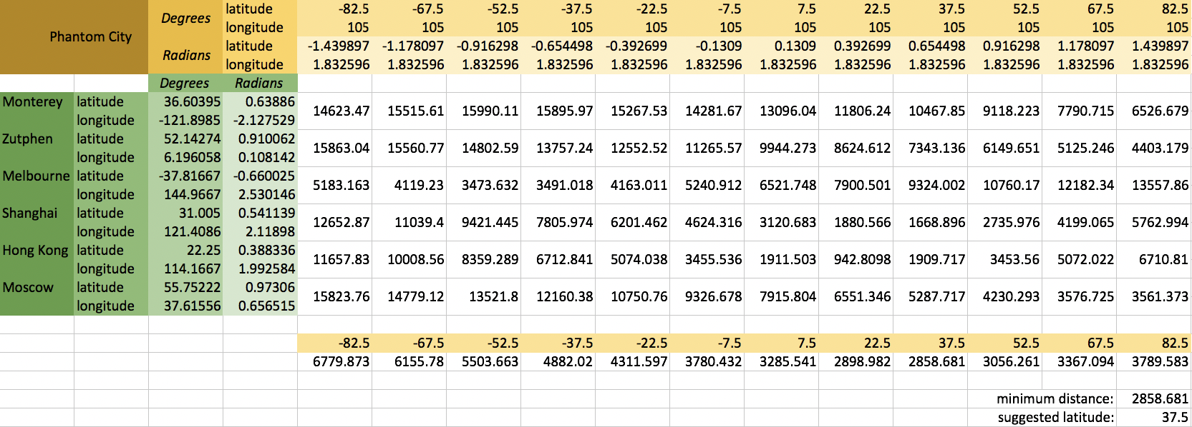
Figure 12: The Excel setup for finding the best latitude (Small Meeting). This can be graphically represented. See Figure 13.

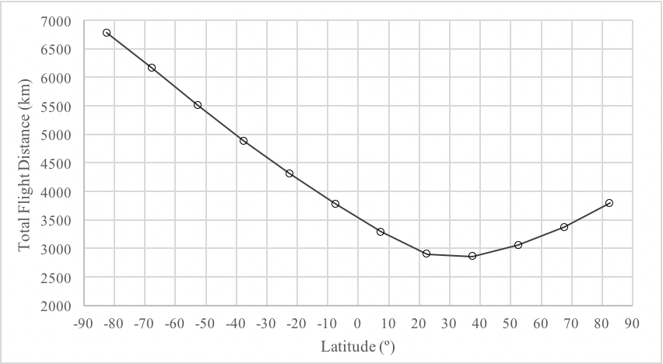
Figure 13: The graph of dtotal against latitude (Small Meeting).
As dtotal and its derivatives are continuous at all points, a smooth curve like this is expected. From this data, we can see that the optimal latitude is 37.5◦. Therefore, the final search region is bounded by 30 ≤ λ ≤ 45 and 97.5 ≤ φ ≤ 112.5.
In that region, there are 5 cities with airports. Noting that the meeting is held mid-June, let us look at their temperatures.
1. Xi’an has an average temperature range of 19 − 30◦C; it is valid. 2. Cheng Du has an average temperature range of 21 − 28◦C; it is valid. 3. Nanchong has an average temperature range of 24 − 32◦C; it is valid. 4. Lanzhou has an average temperature range of 14 − 27◦C; it is valid. 5. Xining has an average temperature range of 9 − 23◦C; it is valid.
As all of them have passed, the final list of recommendations can be generated:

City | Latitude | Longtitude
Xi’an | 35o 15’44”N | 108o 56’16”E
Cheng Du | 30o34’22”N | 104o4’00”E
Nanchong | 30o 47’0”N | 106o 8’0”E
Lanzhou | 36o 3’23”N | 103o 47’32”E
Xining | 36o 37’0”N | 101o 46’0”E

5.2 Large Meeting
The individuals we had to consider are listed in the table below, along with the cities’ timezones and coordinates.
Boston MA, USA ×2 UTC-5
Copenhagen, Denmark UTC+1
Utrecht, Netherlands UTC+1
Moscow, Russia UTC+3
Hong Kong (SAR), China ×2 UTC+8
Warsaw, Poland UTC+1
Singapore UTC+8
Melbourne, Australia UTC+10

Beijing, China UTC+8

Lat. Long.
City
Lat. Long.
Boston MA, USA ×2 42o 21’29”N
71o 3’37”W
Copenhagen, Denmark
55o 40’0”N 12o 35’0”E
Beijing, China 39o 55’44”N
116o 23’18”E Table 5: The coordinates of the cities
Utrecht, Netherlands 52o 5’34.3534”N
5o 6’16.1280”E Moscow, Russia
55o 45’8”N 37o 36’56”E
Hong Kong (SAR), China ×2 22o 15’0”N
Warsaw, Poland 52o 15’0”N
21o 0’0”E
Singapore
1o 22’0”N 103o 48’0”E
Melbourne, Australia 37o 49’0”S
144o 58’0”E
114o 10’0”E
Excel was used to calculate the overall productivity losses L of each city in each timezone, and therefore the total overall productivity losses Ltotal of each timezone. This is shown in Figure 14.
Figure 14: The Excel setup for finding the best timezone (Big meeting).
These values give a graph of Ltotal against timezone, shown in Figure 15.
Similar to the ‘Small Meeting’ scenario, the same ’broken parabolas’ are seen. The optimal timezone is UTC+3, i.e. the longitude range 37.5 − 52.5◦E.
Then we move to Stage 2. Excel was used to determine the region with the lowest dtotal. This is seen in Figure 16.
The graph is shown in Figure 17.
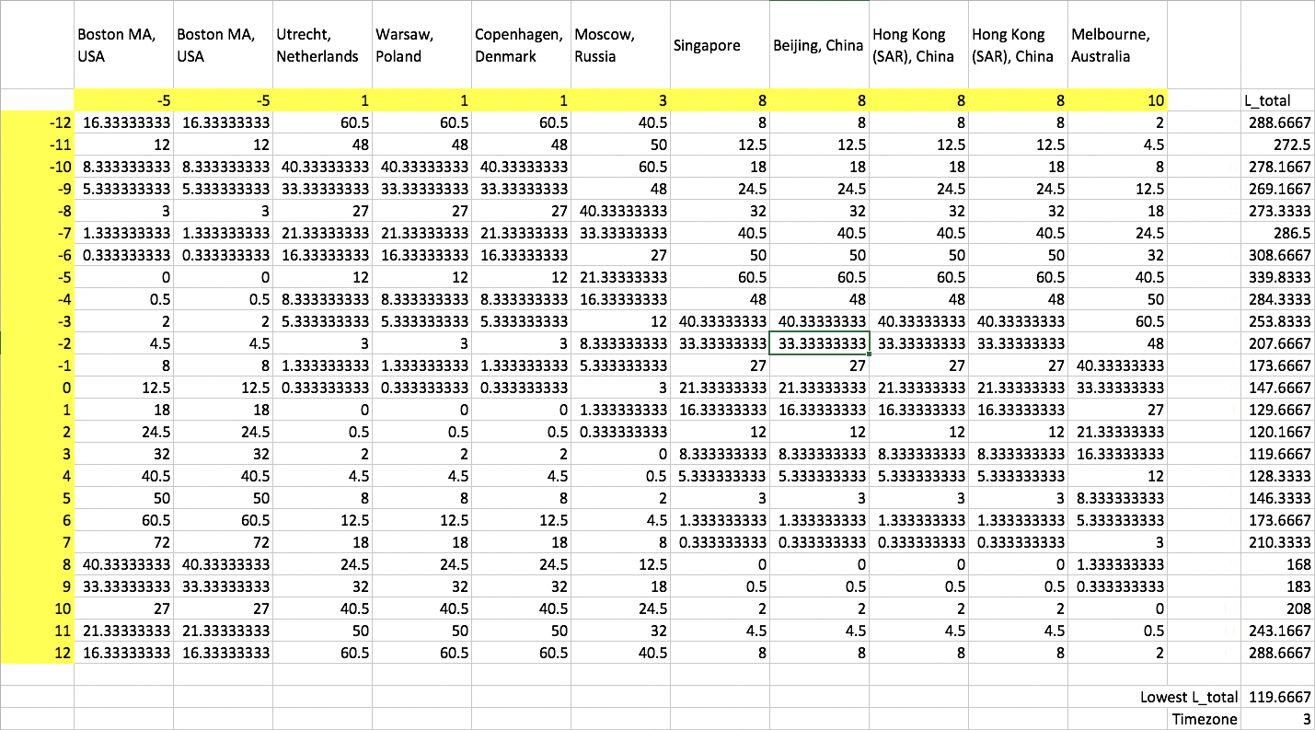

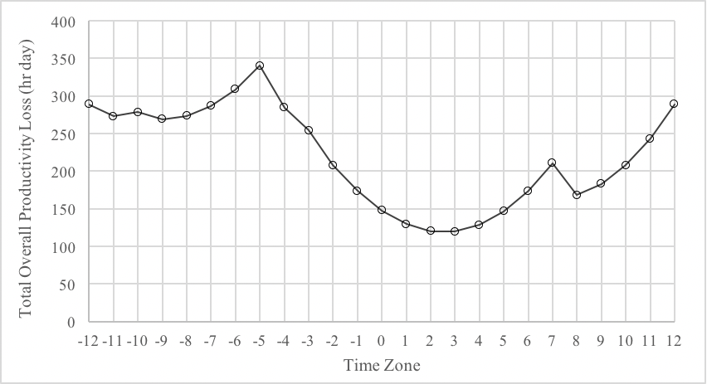
Figure 15: The graph of Ltotal against timezone (Big meeting).
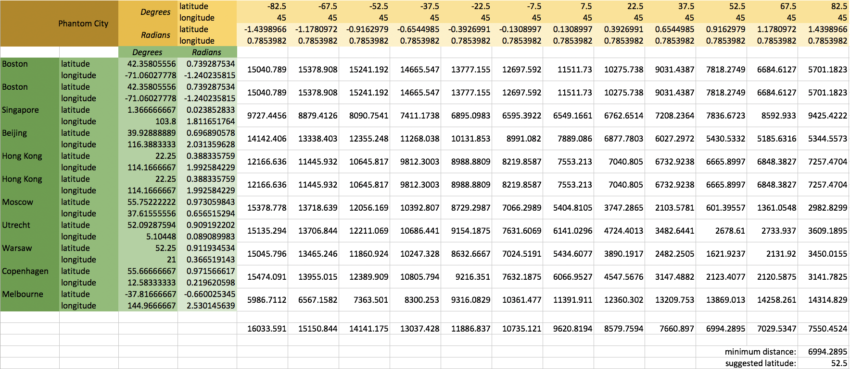
Figure 16: The Excel setup for finding the best latitude (Big Meeting).
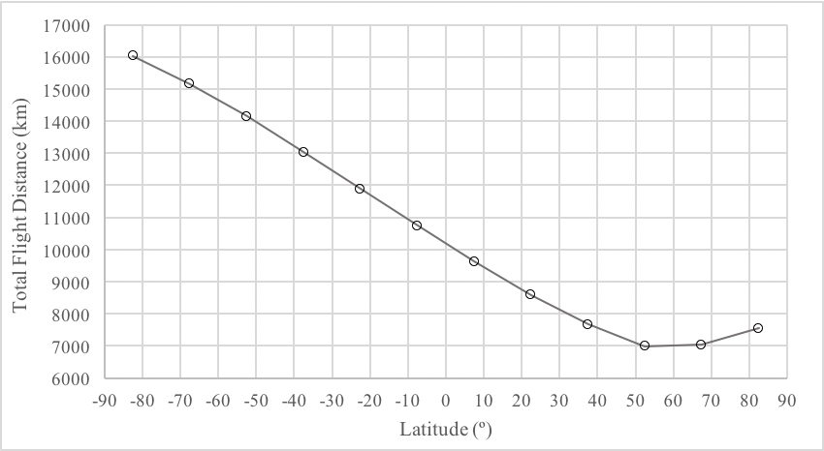
Figure 17: The graph of dtotal against latitude (Big Meeting). 16
Clearly, the latitude 52.5◦N has the lowest dtotal. This gives a search region of to 45 ≤ λ ≤ 60 and 37.5 ≤ φ ≤ 52.5.
Here, we find 11 cities with airports. Noting that the meeting is in January, let us look at each one in turn.
1. Atyrau has an average minimum temperature of −13◦C; it is disqualified.
2. Astrakhan has an average minimum temperature of −12◦C; it is disqualified.
3. Elista has an average minimum temperature of −8◦C; it is disqualified.
4. Krasnodar has an average minimum temperature of −2◦C; it is disqualified.
5. Rostov-On-Don has an average minimum temperature of −5◦C; it is disqualified.
6. Donetsk has an average minimum temperature of −7◦C; it is disqualified.
7. Uralsk has an average minimum temperature of −14◦C; it is disqualified.
8. Voronezh has an average minimum temperature of −11◦C; it is disqualified.
9. Samara has an average minimum temperature of −15◦C; it is disqualified.
10. Kazan has an average minimum temperture of −19◦C; it is disqualified.
11. Moscow has an average minimum temperature of −9◦C; it is disqualified.
12. Nizhniy Novgorod has an average minimum temperature of −12◦C; it is disqualified.
Therefore, there are no valid cities in 45≤λ≤60 and 37.5 ≤φ ≤ 52.5. We move again to 30 ≤ λ ≤ 45 and 37.5 ≤ φ ≤ 52.5. Here, we find 12 cities with airports. Let us look at their climates as well.
1. Aktau has an average minimum temperature of −2◦C; it is disqualified.
2. Ahvaz has an average minimum temperature of 7.2◦C; it is valid.
3. Shahrekord has an average minimum temperature of −8◦C; it is disqualified.
4. Esfahan has an average minimum temperature of −2◦C; it is disqualified.
5. Tehran has an average minimum temperature of −2◦C; it is disqualified.
6. Tabriz has an average minimum temperature of −5.7◦C; it is disqualified.
7. Tbilisi has an average minimum temperature of −1◦C; it is disqualified.
8. Batumi has an average minimum temperature of 3◦C; it is valid.
9. Vladikavkaz has an average minimum temperture of −6◦C; it is disqualified.
10. Nalchik has an average minimum temperature of −7◦C; it is disqualified.
11. Sochi has an average minimum temperature of 3.6◦C; it is valid.
12. Mineralnye Vody has an average minimum temperature of −5.7◦C; it is disqualified.
Therefore, the list of recommended cities can be generated:
City | Latitude | Longtitude
Ahvaz, Iran | 31o 19’13”N | 48o 40’09”E
Batumi, Geogria | 41o 38’45”N | 41o 38’30”E
Sochi, Russia | 43o35’07”N | 39o 43’13”E

6. Strengths and Weaknesses
6.1 Strengths
Strength 1: The whole model is built to withstand all cases that gives people location and time of the year. This means that all meetings can be arranged in this way and isn’t just the two scenarios of the paper.
Strength 2: The model prioritize minimizing distance and maximizing productivity. This means that people attending the meeting will have great productivity.
6.2 Weaknesses
Weakness 1: The effects caused by accidents might create unexpected accidents. However, it is always inevitable.

